EDK II is the framework we use to build UEFI software; it is not the operating system itself. JollyOS is that.

1. Why do we need EDK II?
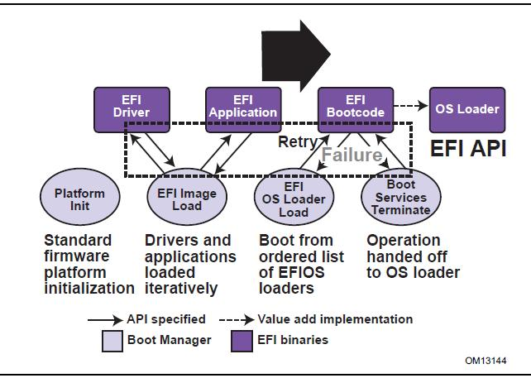
When a PC starts, it runs firmware before any operating system is loaded. On a modern PC, that firmware normally implements UEFI.
EDK II is an open-source implementation and development framework for UEFI. It gives us the tools and libraries to build software that runs in that pre-OS environment.
For JollyOS, the boot process looks roughly like this:
1. PC firmware
UEFI initialises the hardware
2. JollyOS UEFI bootloader
Built using EDK II tools and libraries
3. JollyOS kernel
Our own assembly and C code
4. JollyOS takes control
Kernel initialisation, exceptions, memory management and devices
EDK II helps us produce the UEFI bootloader that runs at step 2. Our kernel at step 3 is separate software, and it does not need to be an EDK II application.

What EDK II provides
- UEFI interfaces: access to firmware services, such as loading files and allocating memory.
- Build infrastructure: compiles and links UEFI modules into EFI executables.
- Libraries: reusable code for common UEFI operations.
- Platform configuration: describes which modules and libraries are needed to build a particular firmware or application.
- Packaging tools: assemble the output into the appropriate EFI files or firmware images, depending on the build target.
We could write a UEFI application without using the full EDK II build framework, but we'd need to provide or configure the UEFI headers, libraries, linker settings and build process ourselves. EDK II saves us a lot of that work.

2. What do .DSC, .DEC and .INF files do?
These files are the build system's instructions. They are not executable code and are not files that the PC runs directly.
The official EDK II documentation describes them as different layers of build configuration.

.DSC
Platform Description — the build plan
Specifies which UEFI modules to build, which library implementations to use, and which configuration values apply to the platform.
Think: What are we building, and how do its parts fit together?

.DEC
Package Declaration — the public definitions
Declares what a package exposes, including header directories, library classes, GUIDs, protocols and configuration tokens (PCDs).
Think: What definitions and interfaces does this package provide?

.INF
Module Information — the individual component
Lists the source files, package dependencies, library classes and module type for one component, such as a UEFI application or driver.
Think: What files make up this component, and what does it need to compile?

How they work together
Imagine we create a UEFI application called JollyLoader.
Its files might look like this:
C:\edk2\
│
├── JollyOSPkg\
│ ├── JollyOSPkg.dec
│ │
│ ├── JollyLoader\
│ │ ├── JollyLoader.inf
│ │ ├── JollyLoader.c
│ │ └── EntryPoint.asm
│ │
│ └── JollyOSPkg.dsc
│
├── MdePkg\
│ └── MdePkg.dec
│
└── ...
This is an illustrative layout; we haven't created all these files yet.
The build process follows this logic:
JollyOSPkg.dsc
Selects JollyLoader.inf and its library implementations
JollyLoader.inf
Identifies JollyLoader.c, EntryPoint.asm and dependencies
JollyOSPkg.dec and MdePkg.dec
Provide package declarations and interfaces used by the module
JollyLoader.efi
The compiled UEFI executable
The build tools use these files together to compile and link the application. The .DEC does not compile the code itself, and the .DSC is not the executable.

3. What about .FDF?
There is another important file in EDK II: .FDF, or Flash Description File.
It describes how modules are packaged into firmware images or firmware volumes. For example, it is relevant when building a complete UEFI firmware image for a particular platform.

For JollyOS, we normally want to build an EFI bootloader file, not replace the PC's firmware. Therefore, we don't need to build a complete firmware image just to create JollyLoader.efi.

4. How this relates to your current EDK II setup
From the configuration you previously showed me, your C:\edk2\Conf\target.txt currently contains:
ACTIVE_PLATFORM = EmulatorPkg/EmulatorPkg.dsc
TARGET_ARCH = IA32
TOOL_CHAIN_TAG = VS2022
Those settings matter:
Setting | Current meaning | What JollyOS needs
ACTIVE_PLATFORM | Builds the EDK II emulator platform | A platform configuration for our loader
TARGET_ARCH | Builds for 32-bit IA32 | X64 for our x86-64 UEFI loader
TOOL_CHAIN_TAG | Selects the VS2022 toolchain definition | A compatible toolchain configuration for our VS2026 installation
Your existing settings are not necessarily wrong for building the emulator sample, but they are not yet the intended configuration for our own x86-64 JollyOS loader.
The VS2026 issue is a separate matter: even though your EDK II tools_def.txt contains VS2026 definitions, we must ensure the selected toolchain definition and the compiler environment agree.

5. What should we do next
We should create a small, dedicated EDK II package for JollyOS rather than modifying the emulator platform to serve as our loader.
The work would be:
- Create JollyOSPkg.dec for our package declarations.
- Create JollyLoader.inf for the loader's C and assembly files.
- Create JollyOSPkg.dsc to select the loader and its required libraries.
- Configure the build for X64 and the working Visual Studio toolchain.
- Build and verify JollyLoader.efi, then test it in VMware.
Our existing kernel remains separate: the loader will initialise the UEFI-side environment, load the kernel and pass the boot information it needs.
The advantage is that JollyOS gets its own build configuration, independently of the EDK II emulator sample. We can then extend the loader without making changes to EDK II's example platform.

